

**#INTRO**

1.It is a database server where we can store huge amount of data.

2.Mongo🡪 means huge

3.It is schemaless not like MySQL which has tables.

4.Highly scalable

5. 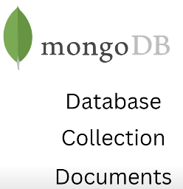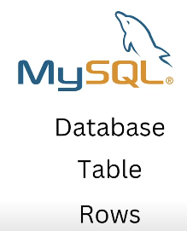

6.Here documents are stored in JSON format.

7.Thus it doesnot have schema so same collections can have diff type of data. 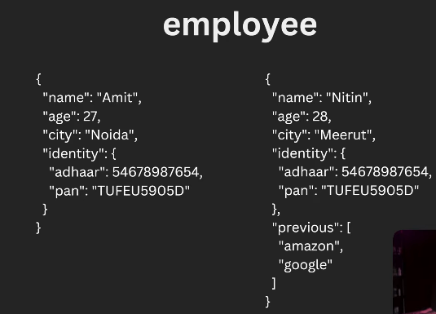

8.Flexibility increases as just add info without making any tables or rows. 

9. 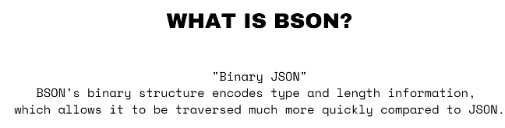

10.We know that document is stored in the JSON format but behind the seen it is stored in BSON format.

11.That is Binary Representation of JSON, conversion of JSON in binary which increases its traversal.

**#INSTALLATION**

1. 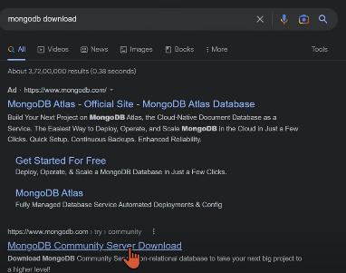

2.We have two methods to interact with mongoDB

a.With MongoDB GUI   
b.Windows shell.

3.It starts as a services in our window and if we want to disconnect then we can do so.   
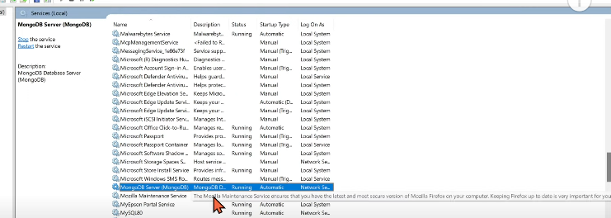

4.Or we can disconnect it using cmd dministrator.

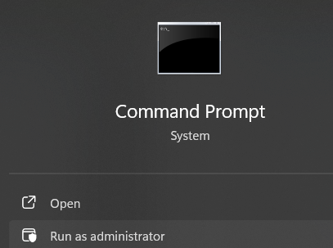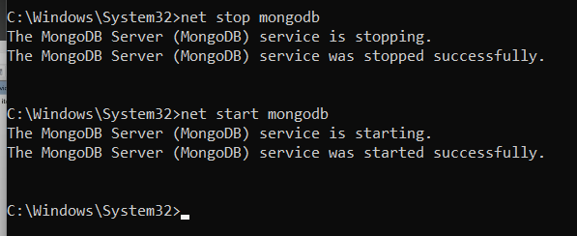

“net stop mongodb” …….. “net start mongodb”

5.For running queries we have to download mongosh shell

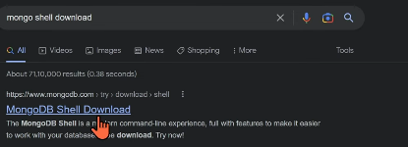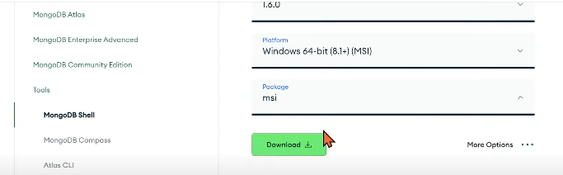

6. 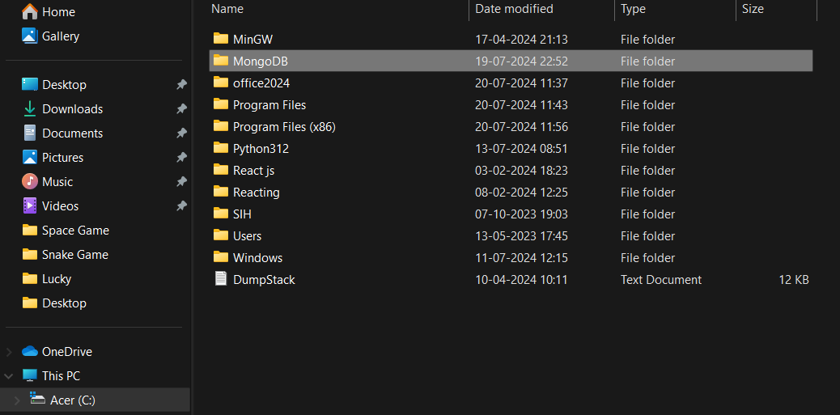

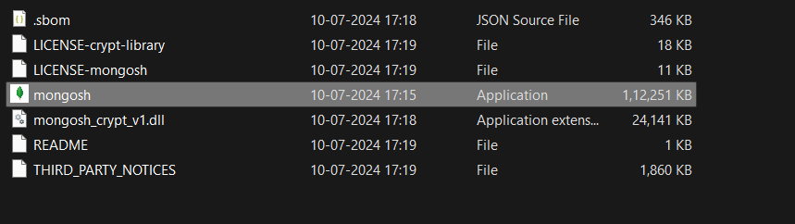

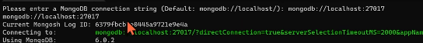

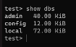 By default dbs.

7.ctrl+c 🡪 for closing mongo shell, ctrl+l🡪for clearing the screen

**#CREATING DB IN MONGODB SERVER**

1.For creating a db we can use mongo shell or GUI.

2.First see how we can create db using mongo shell

3.Press enter to set current log id:

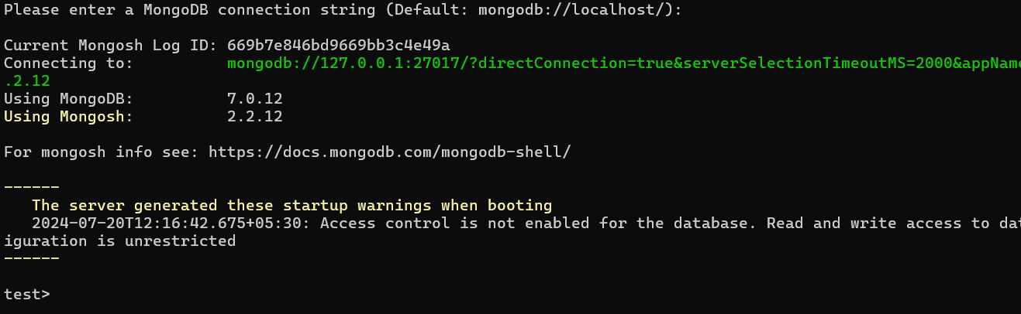

4.ctrl+L🡪 clear picture

5.show db 🡪 gives the current dbs

6.use db_name🡪if already a db created with name “db_name” then take you their otherwise make a new db with that name. 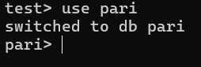

7.Now in db if we want to create a collection just write “db.collection_name” 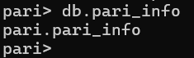

8.For creating a file in collection use “.insertOne({x:y})”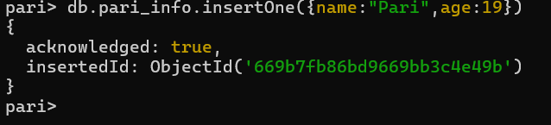

9. To check check existing file use “.find()”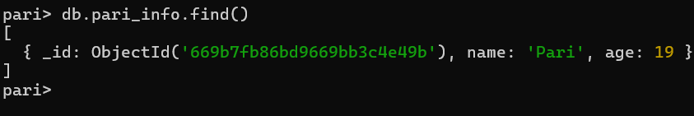

Here id is a unique identifier of each document.

**#UPDATING A DOCUMENT**

1. 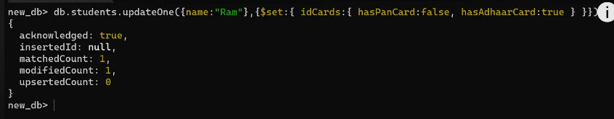
2. 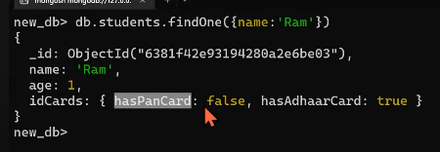
3. Updating all documents of a collection at the same time:  
   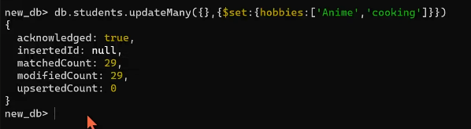
4. Finding:  
   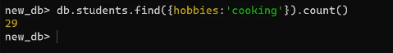

**#NESTED DOCUMENT IN DB**

1.Also called embedded document

2.Searching in nested document: 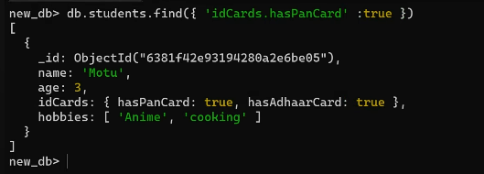

3.

**#CRUD OPERATIONS**

1. 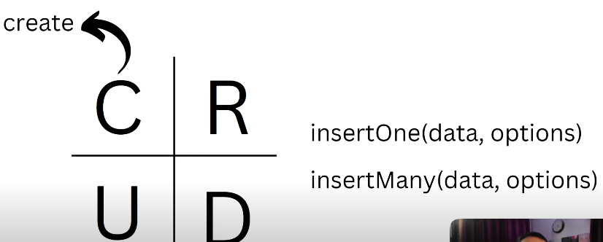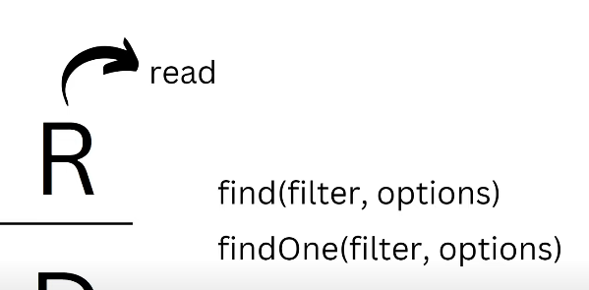

2. 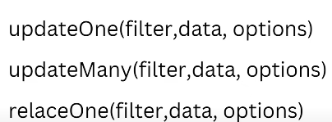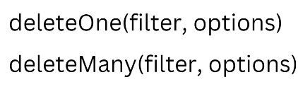

3. 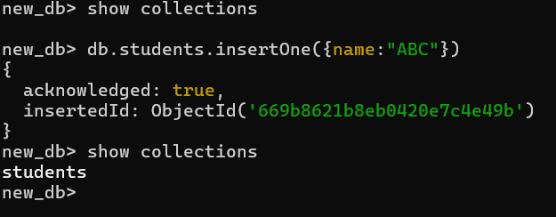

4. 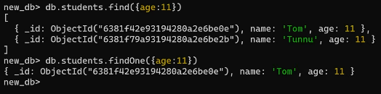

5. 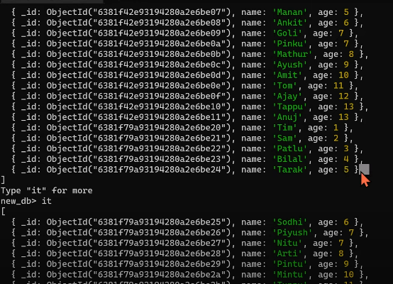

6. 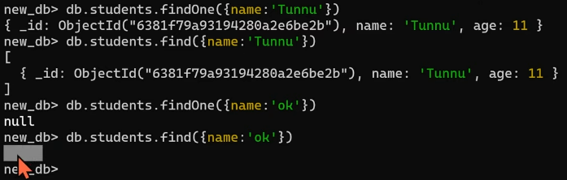

“.findOne()”🡪returns null if not found

“.find()”🡪returns cursor if not found

7.Counting total no of documents:

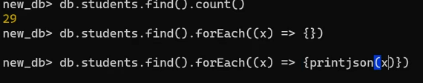

8. Printing all the documents in a collection: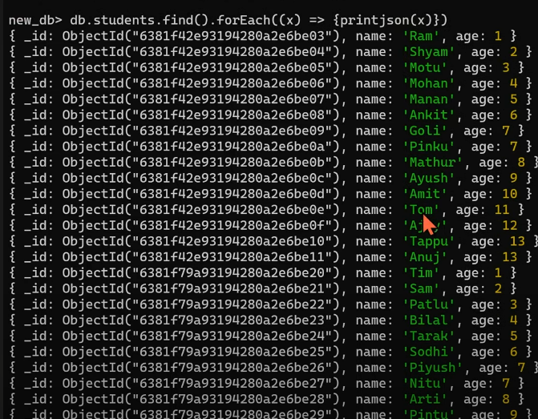

9. 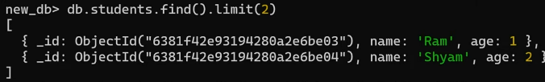

10.Conditional finding: 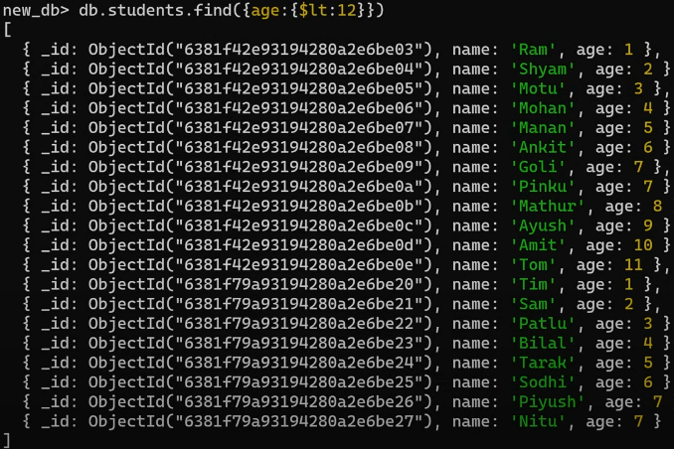

11.$-->indicates follows a reserved keyword that only mongoDB understands.

12.Finding in limit:  
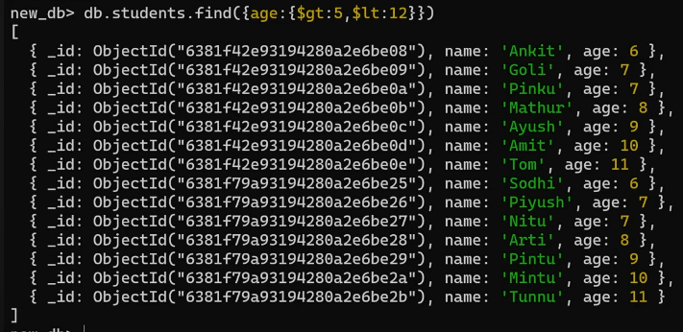

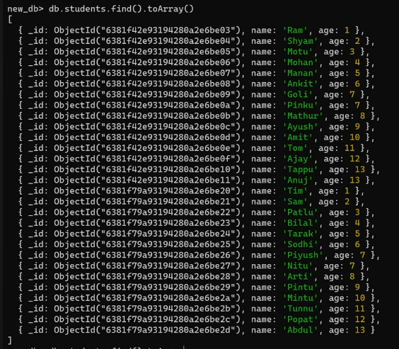

**#CREATE IN CRUD**

1. 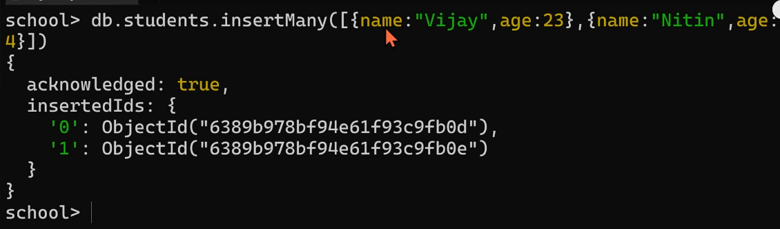
2. 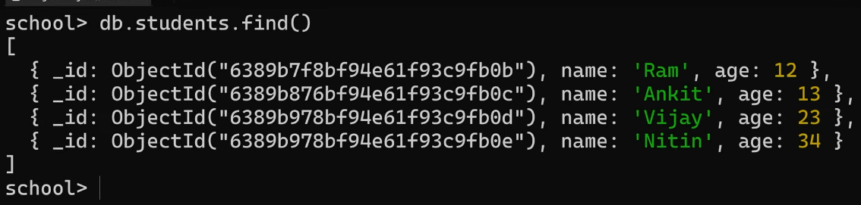
3. 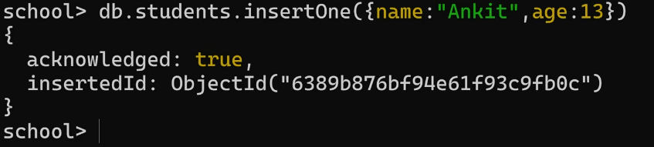
4. 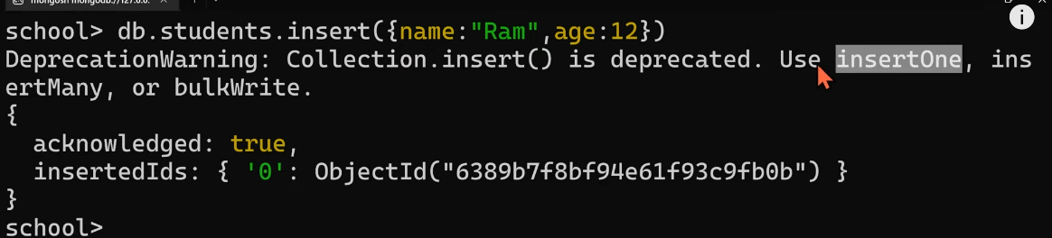

**#UPDATE DOCUMENT**

1. To update an existing document we can use the updateOne() or updateMany() methods.
2. The first parameter is a query object to define which document or documents should be updated.
3. The second parameter is an object defining the updated data.
4. The updateOne() method will update the first document that is found matching the provided query.

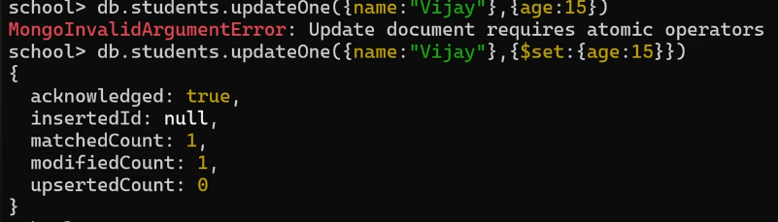

5. The updateMany() method will update all documents that match the provided query.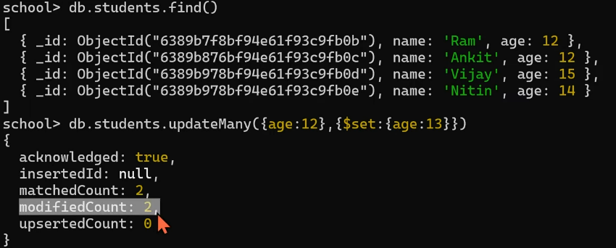

6.If we are updating a field which is not even available in the document then it will just create in it.

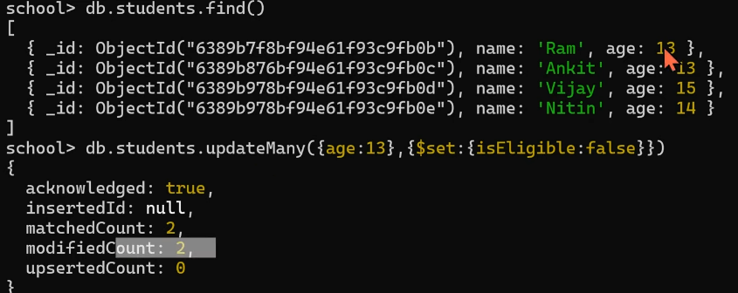

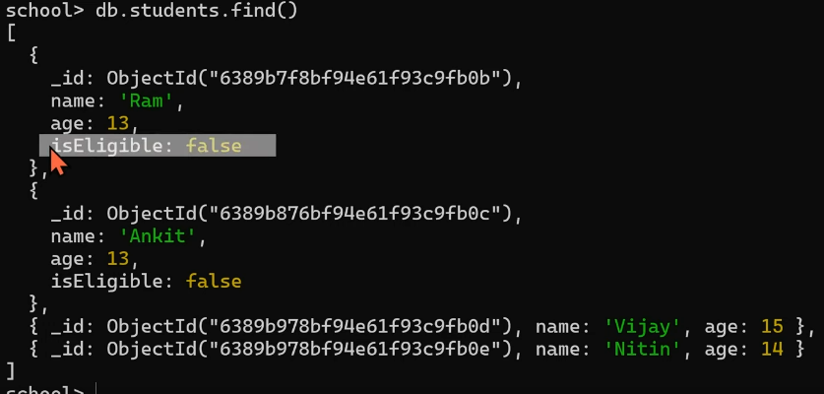7.We can also update our document by applying the conditional like $gte



**#DELETE DOCUMENT**

1. The deleteOne() method will delete the first document that matches the query provided. 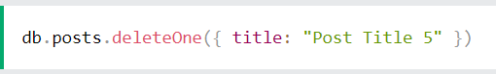

2. The deleteMany() method will delete all documents that match the query provided. 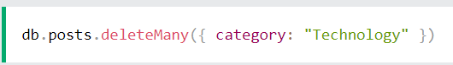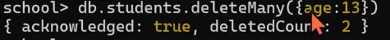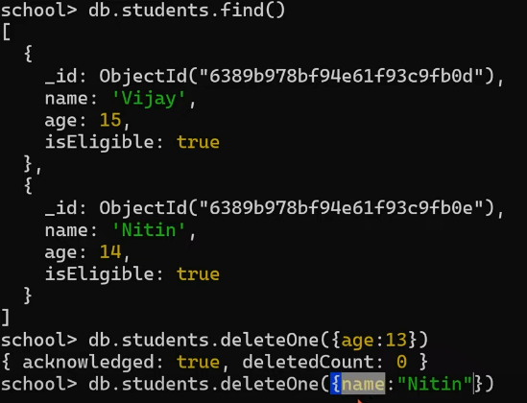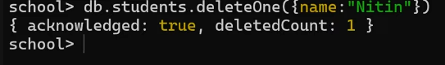

3.For deleting all data of document just pass empty curly braces “{}”

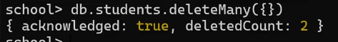

You can’t skip the {} as it shows the empty json of document int the collection. 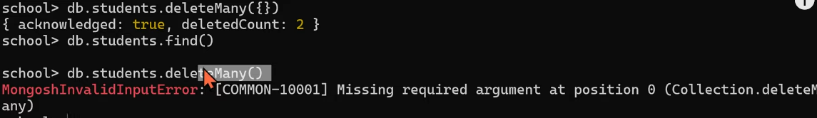

**#SELECT COLUMN QUERY**

1.It means to select only selected info of some employee we just pass that wanted field and give value one.

For ex. “{name:1}” 🡪 we want only name

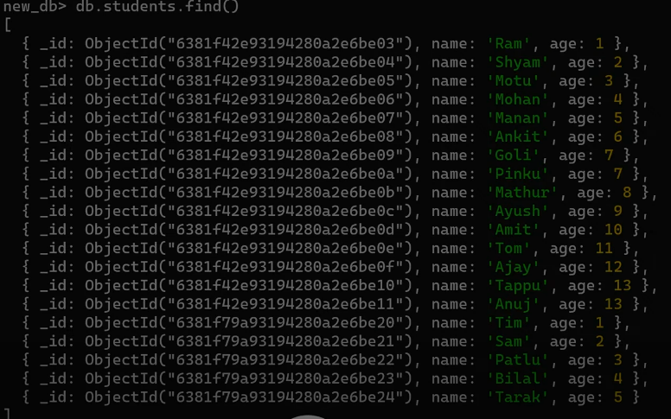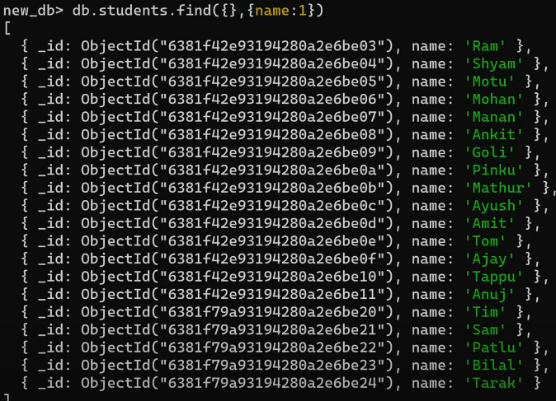

2.But you can see here id is also coming along with the name it was because id is by-default inclusive.

3.If you want to remove the id parameter just pass

“{name:1,_id:0}” 🡪 now here bydefault age and other parama is zero. 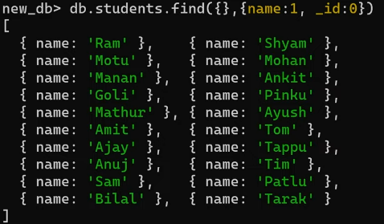

**#IS MONGODB REALLY SCHEMALESS ?**

1. MongoDB is often described as "schemaless," but this can be a bit misleading. What it really means is that MongoDB doesn't enforce a fixed schema at the database level like traditional SQL databases do. This flexibility allows you to store documents with different structures within the same collection.
2. In summary, while MongoDB is schema-less in terms of not requiring a predefined schema, you have the option to apply schema validation rules if you need to enforce some level of structure.
3. 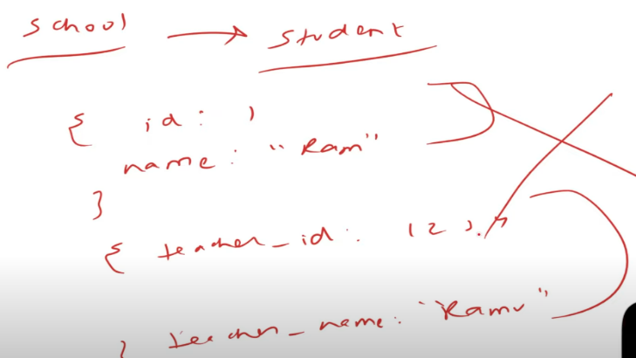Means we have to maintaine some type of schema as …..somehow mongoDb allow us to add any structure data but it may make some chaos.

**#DATA TYPES IN MONGODB**

1.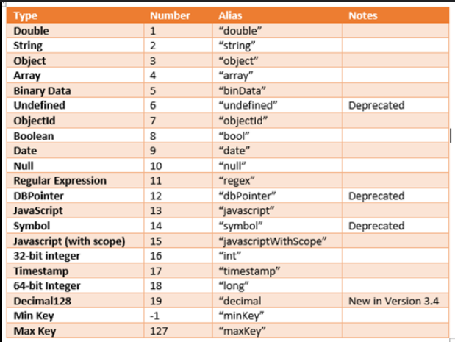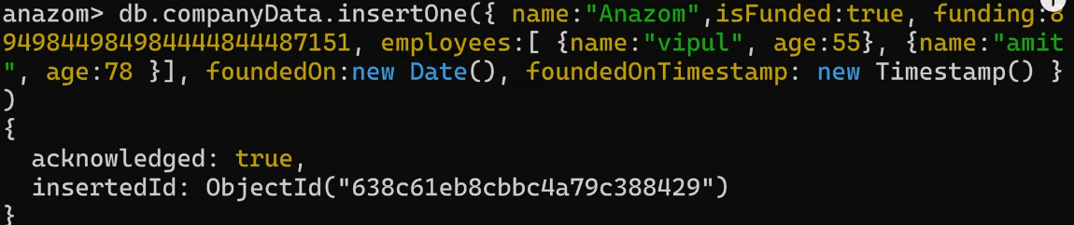

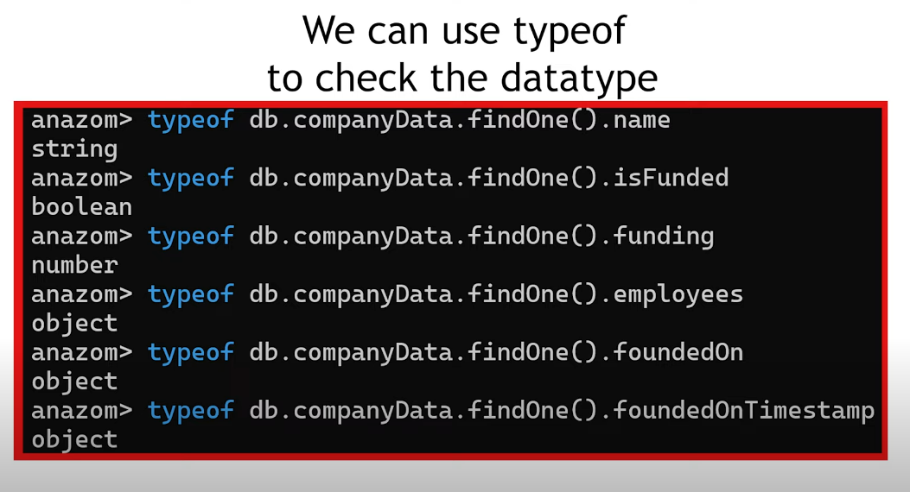

**#DELETE DATABASE IN MONGODB**

1. 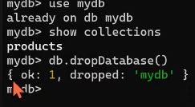

2. 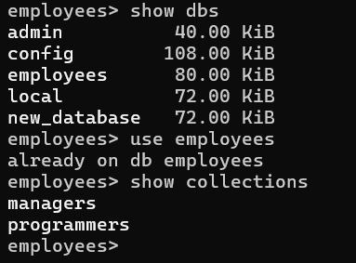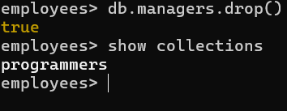

4.For dropping the whole db collections then use: “db.dropDatabase()”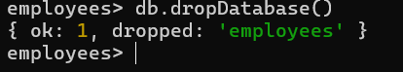

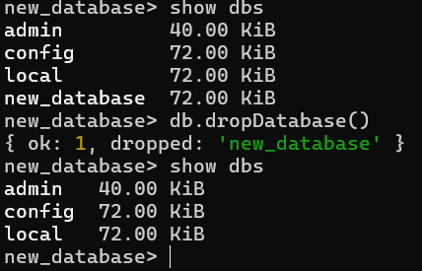

**#ORDERED OPTIONS IN INSERT**

1. 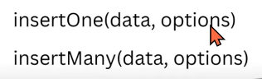

2.Fisrt argument of insert is data which always takes a list and section is options. 

3.We know that the id given is always by-default by the system. 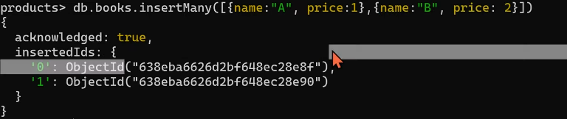

4.So for giving a choice id you can do it by passing as a option in param. But you can’t changes id after creation.So delete the db if id is by default created 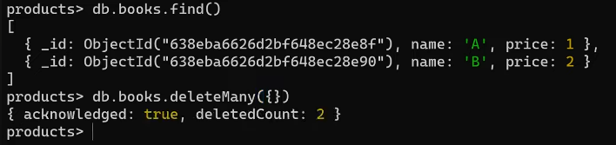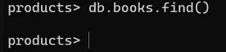

5.Now at a time of creation put “_id:x” in data param 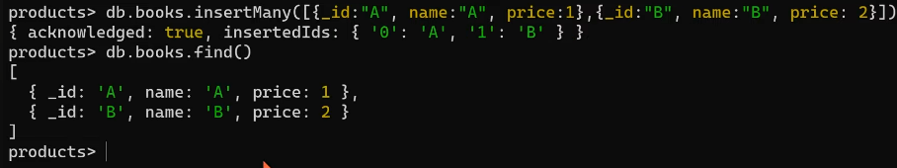

6.If we want to create the document with the existing id then mongoshell gives us an error. As we can’t create two documents with the same ids.

7.Our insert command works left to right so if an error comes on then our creation stops their. No more documents will create after that.

For ex. Suppose we create 3 documents with ids c,a,e but in this a id is already exists so it will give error and due to it document with id e will also not able to create.Here only document with Id c will create only. 

8.So to ignore only error part and continue the creation just use options “{ordered:false}”

Here we know error will come at id a but id e will be created 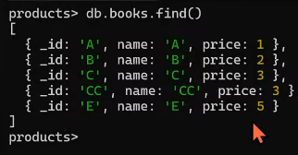

**#Practice**

1. 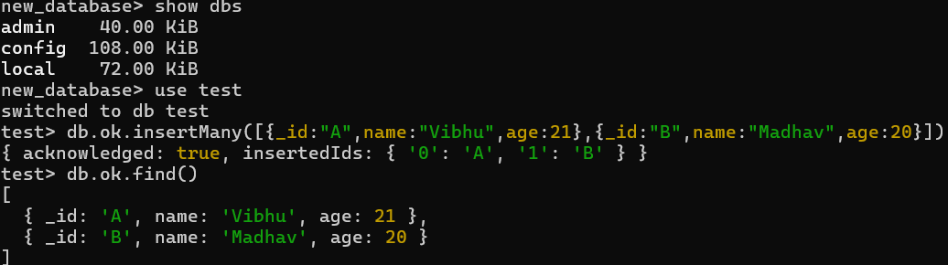

2. 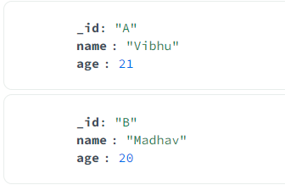

3. 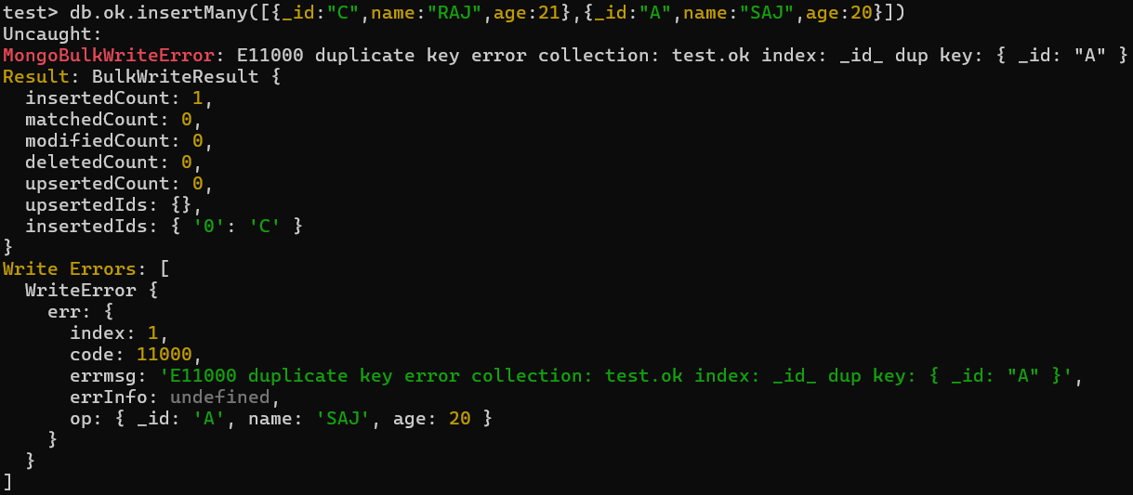

4. 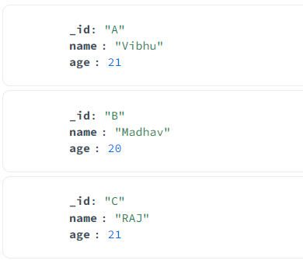

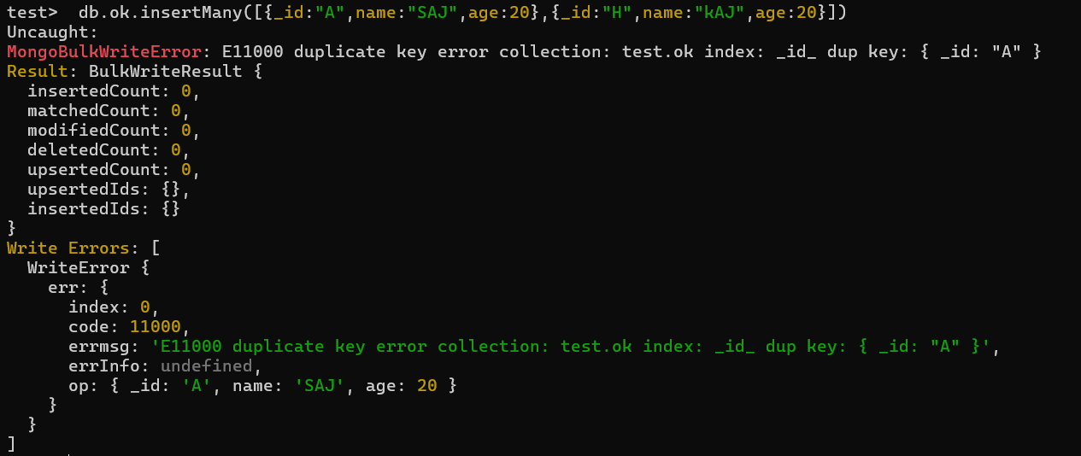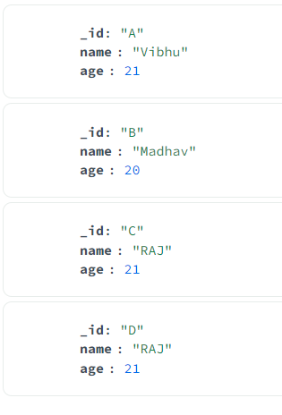

Id:H is not created as error comes at id:A so now to continue creation after error just pass options.

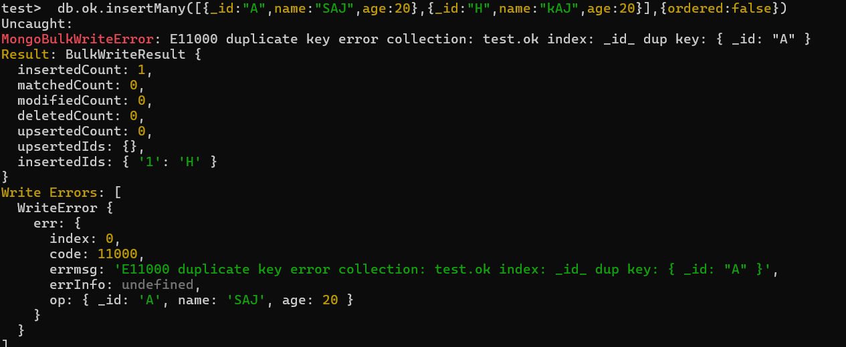

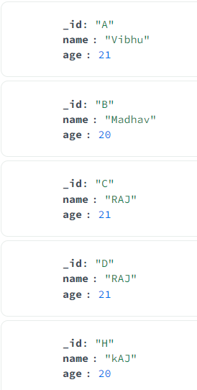

**#SCHEMA VALIDATION**

1.MongoDB has a feature called schema validation that allows you to apply constraints on your documents' structure.

2.To create collection without adding a document in it 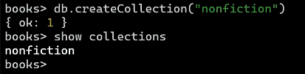

3. Schema validation is built around JSON Schema, an open standard for JSON document structure description and validation.

4.It is used to achieve a valid input while creating a document.

5.For ex. If we gave no. in the the field of name then it should gave us an error.

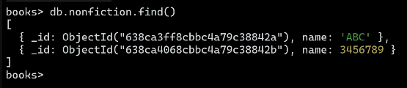

Should not make an document like this.

6.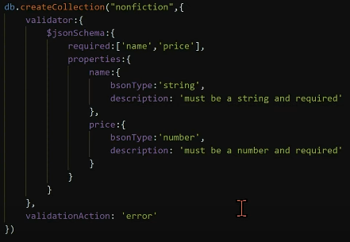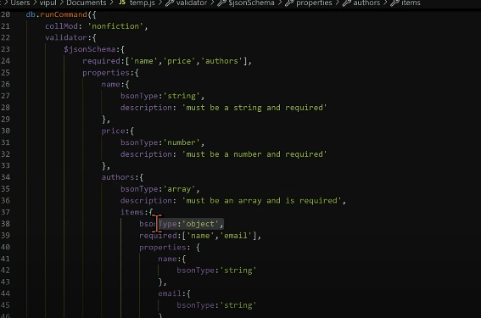

**#WRITE CONCERN OPTION IN INSERT**

1. 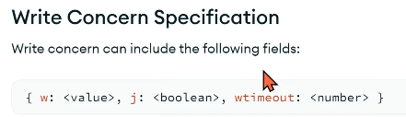

2.wtimeout 🡪Here timeout is the limit time after which if a document creation takes then creation will stop automatically.

3. j 🡪 journel is just like todo it will save the current operation which is ongoing which helps if our server crash or stops. So that when restart journel will tell us where to start again.

4.w 🡪 this option to request acknowledgement if w:1 that means we want ack and if w:0 then we didn’t need ack.

5.If w:0 then the operation become fast as time to send saved is saved.

6.If j:false then also operation become fast.

7. 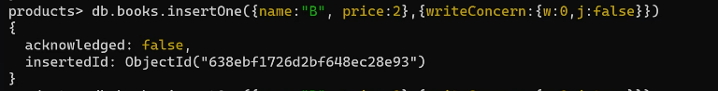

**#ATOMICITY**

1.MongoDB ensures atomicity at the document level, ensuring that all changes within a document operation are either fully committed or fully rolled back in case of failure. This prevents partial updates and data corruption.

**#MONGOIMPORT**

1.If you want to import the json file directly to MongoDB shell, then you have first mongoImport which is not come with mongoShell.

2.So have to download it 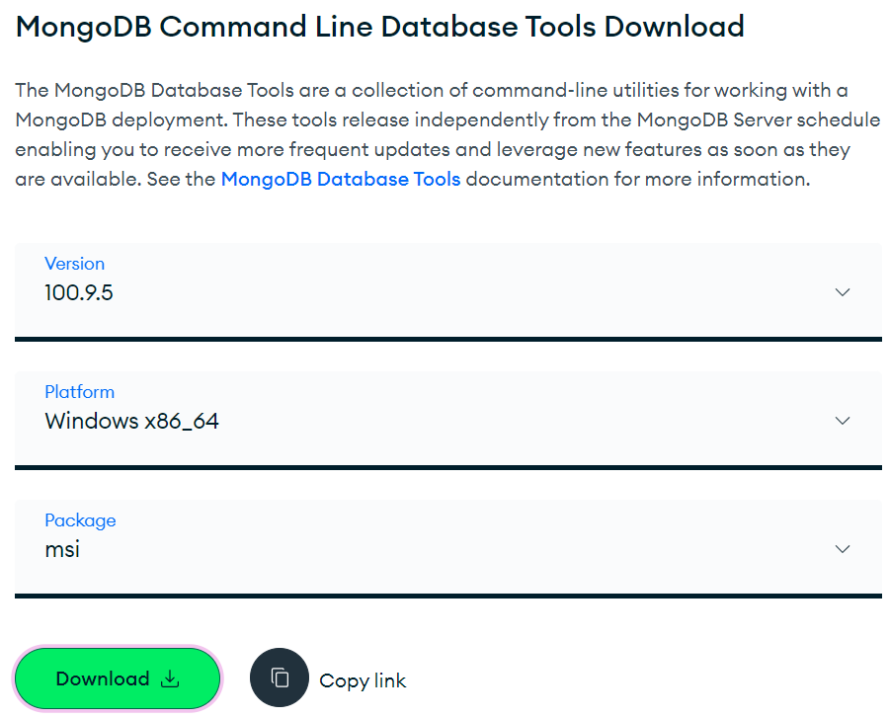

https://www.mongodb.com/try/download/database-tools

3.Then go to its location 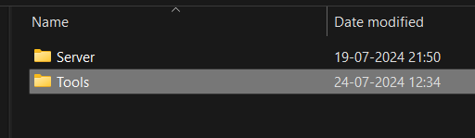

4.Copy the path till bin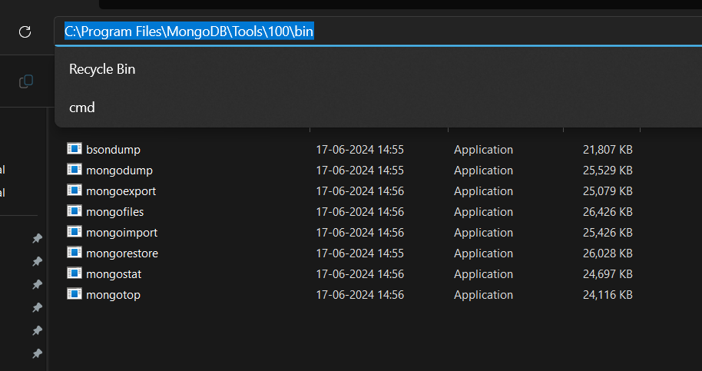

5.It is done so that we can directly use it as import mongo. 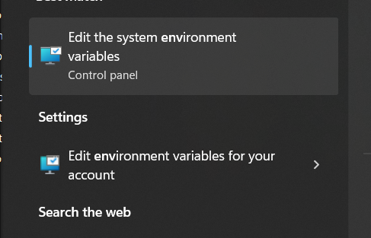

6.First we have to add that path to our sysytem so that we have not to add path everytime. 

7. 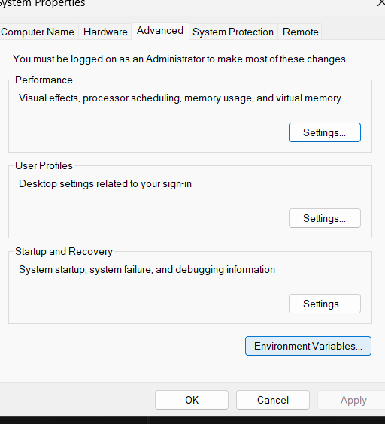

8. 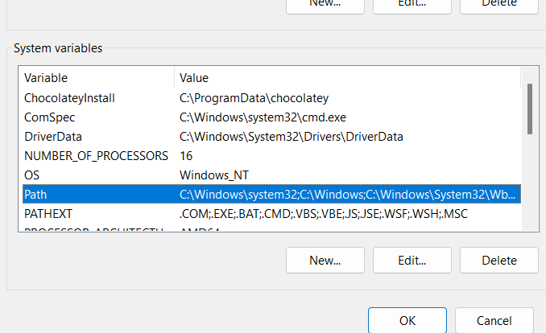

9.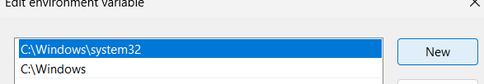

10. Now first put your json file in some folder and copy its path. 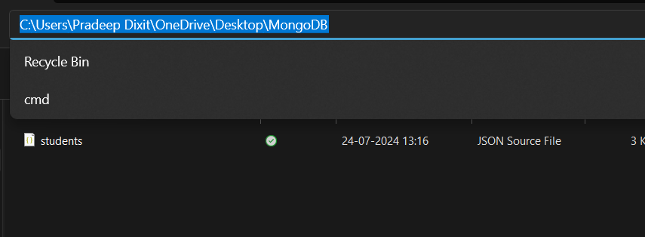

11.Now as you are using server so first start server then open cmd and type “mongoimport "C:\Users\Pradeep Dixit\OneDrive\Desktop\MongoDB\students.json" -d college -c students --jsonArray –drop”

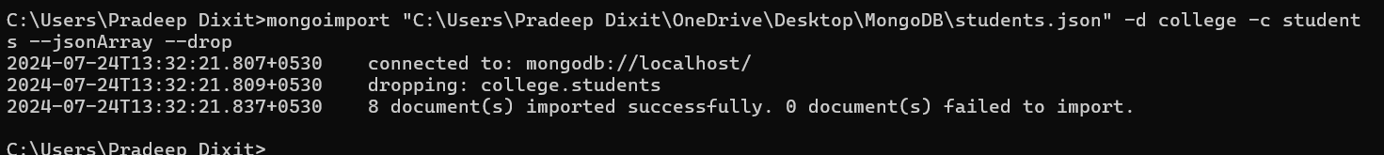

11. Only for importing we use cmd.

12.Now for checking the file we use mongo shell or GUI.

13. 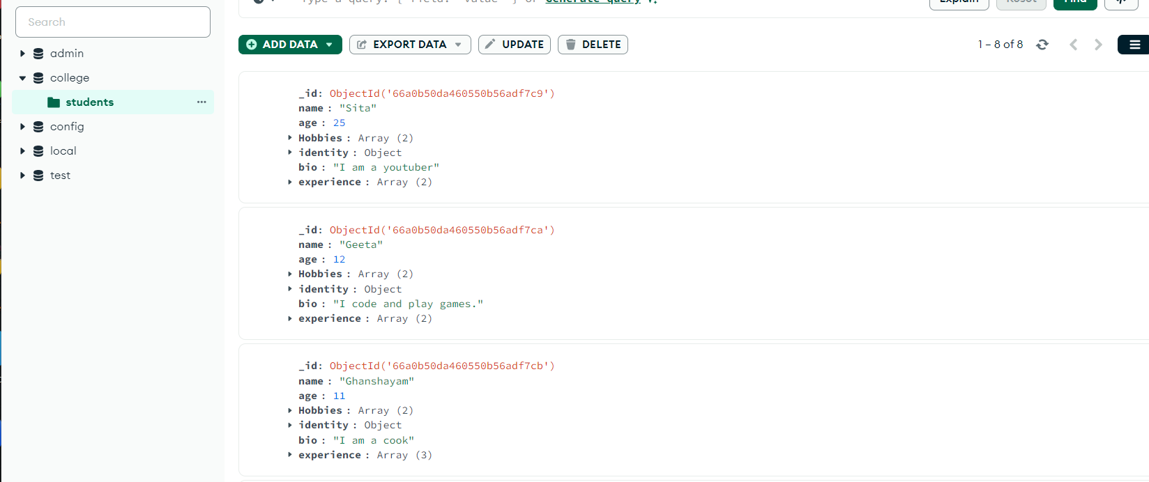

14. 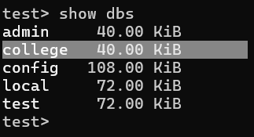

**#COMPARISON OPERATORS**

1. 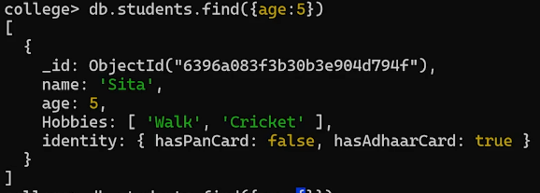

2. 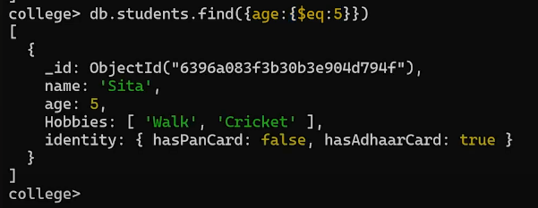

3. 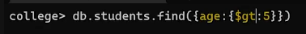

4. 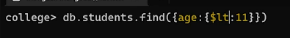

5. 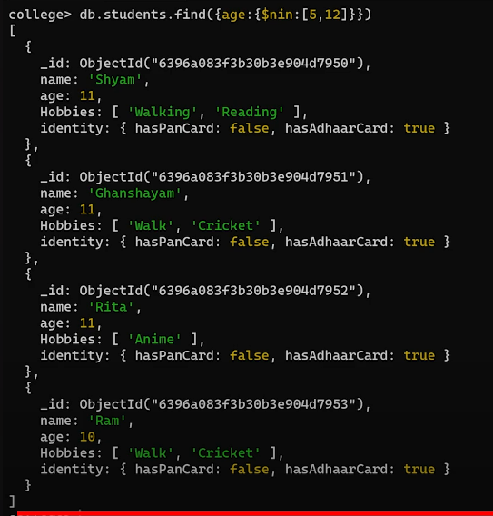

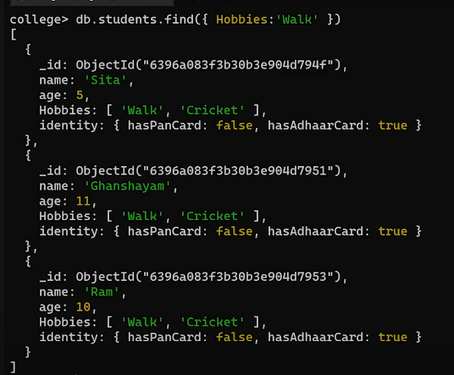

6.For nested search we use dot operator inside the string 

**#LOGICAL OPERATORS**

1. 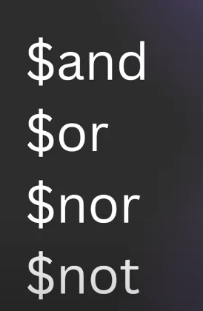

2. 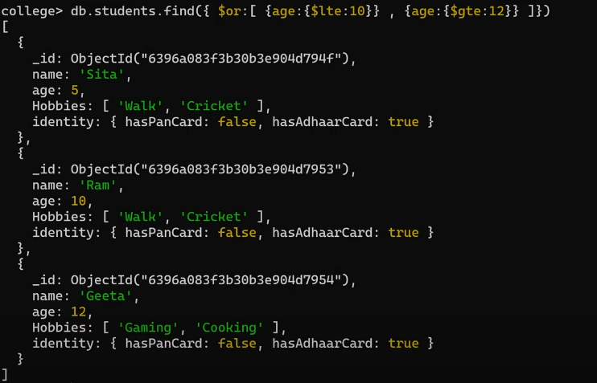

**#ELEMENT QUERY OPERATORS**

1. 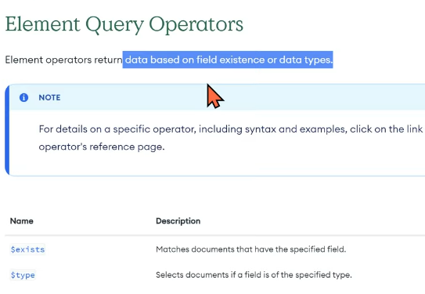

2.These are just used to check the existence of a data field.

3. 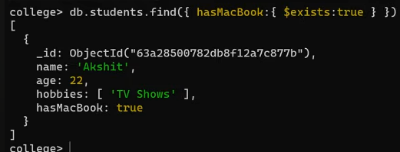

4.$type 🡪 it is used to check whether the data field has the check.

5.Here type:8 is the alias for Boolean 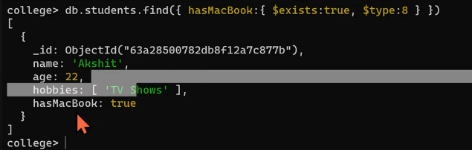 typed or not.

6.We have also some alias to put to search for some type. 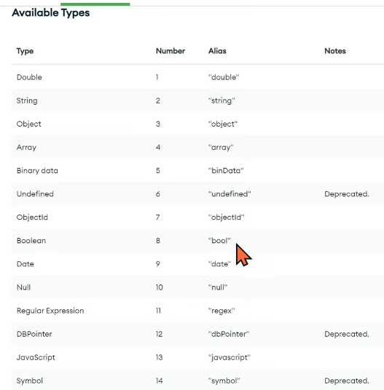

7. So we can either put the type or its alias ok.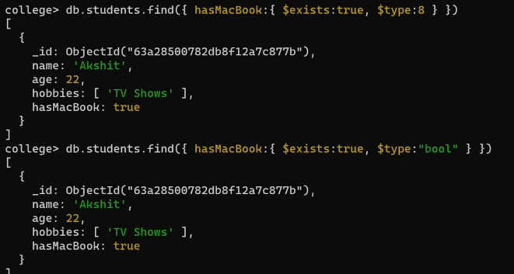

**#EVALUATION QUERY OPERATORS**

1. 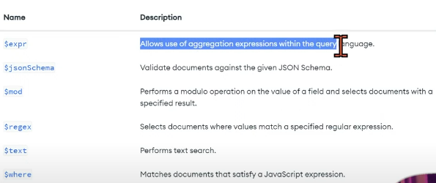

2. 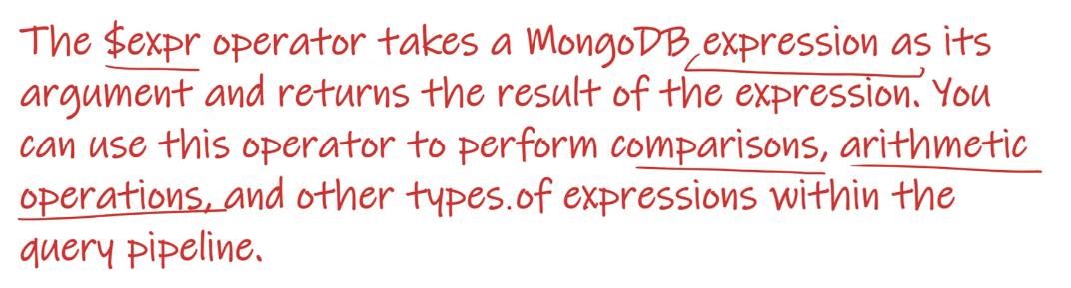

3.So expre takes some list or an array and gives the output data field with comperission or some operation 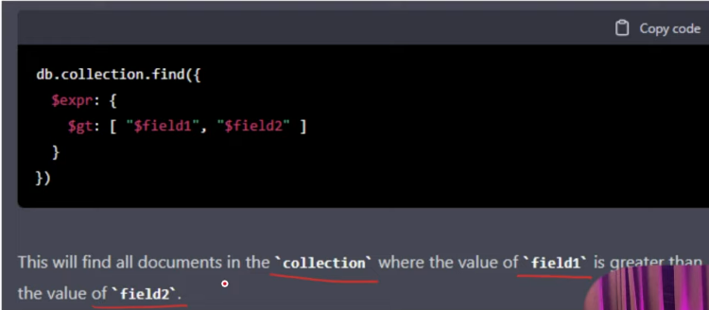

4.expr 🡪 comes from version 3.6 of MongoDB.

5.$regex 🡪 is used to check some string with the given type of pattern.Regular Expression.

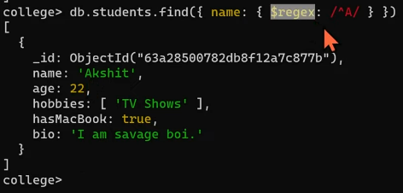Here we are checking a regular expression wehere the A comes first in a string.

6.$text🡪 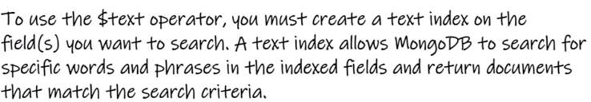

First creating the text as indexed based: 

7.Now we can search for the given text:  
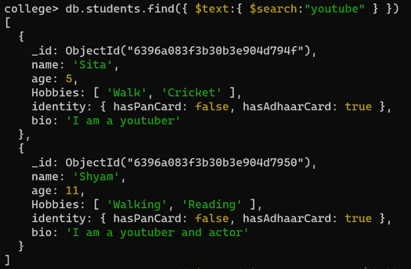

8. 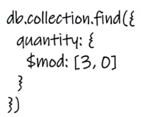DB mai uss collection ko nikalo jisme field quantity hai and uski value ko 3 se divide karne par 0 aaye.

9.If we have to find the even data value just can use “$mod:[2,0]”

10. 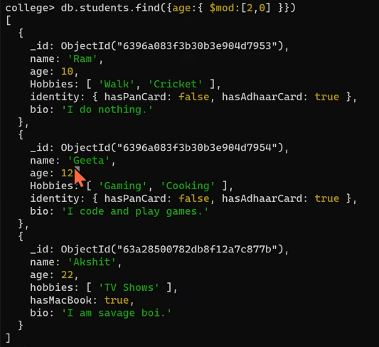

**#EFFORTLESSLY SORT DOCUMENTS**

1.For sorting any document first we have to require the data field along which we have to sort.

2. 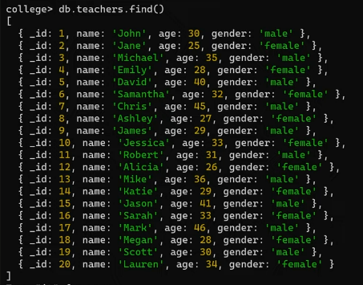Suppose we have this document.

3.To sort the order we can use “db.collection_name.find().sort({field_name:1})

Here 1 🡪 ascending order sorting

-1 🡪 descending order sorting

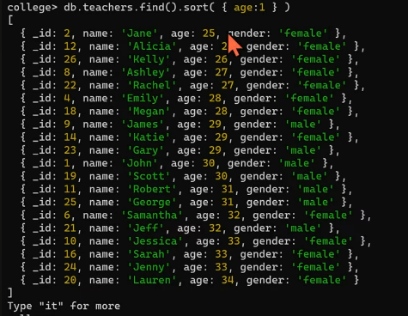

4.Suppose we have to members in the data field with the same age then what can we do??

We just pass another data field along which we have to sort.

5. 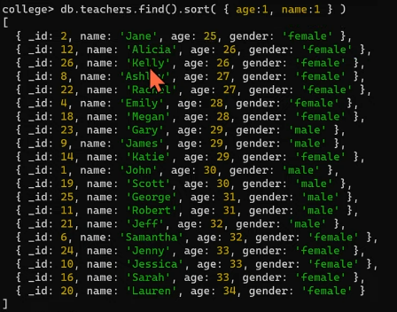Here age:26 has to members thus we pass name:1 now they sort according to their name.

**#NOTE**

1.In mongoshell only fisrt 20 document members are printed by default. For printing more type “it”. 

2.Or we can use foreach loop to print all the data members. 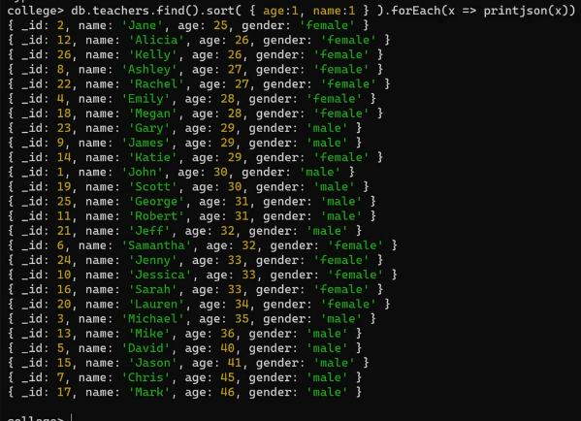

3.We know that MongoDB use js features thus can use js forEach().

4.We have more methods of cursor like.

5.skip(20) 🡪 will skip the first 20 data mebers of the cursor.

6.limit(20) 🡪 will only print first 20.

**#ADVANCED UPDATES**

1. 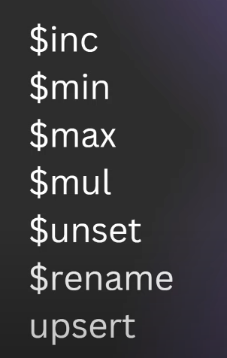

2.$inc 🡪 It takes json and increase the provided field.

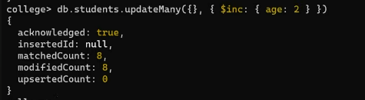

As for increasing our data will updated thus we have to use updateOne() or updateMany().

Now here updateMany() field first takes the data upnon which the operation will be made.

In this case the json{} is empty mens we have to apply on all documents.

Now all documents with or without the age field got updated.

For decreasing the data field we can just pass “$inc :{age:-2}”

3. 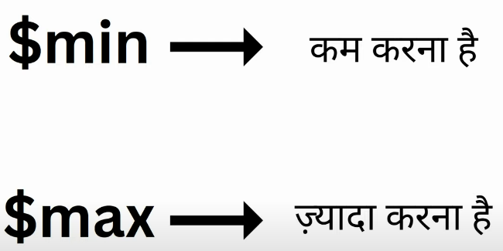

4.$min 🡪 agar existing value badi hai toh use kam karke hamari di gai value par set kar do.

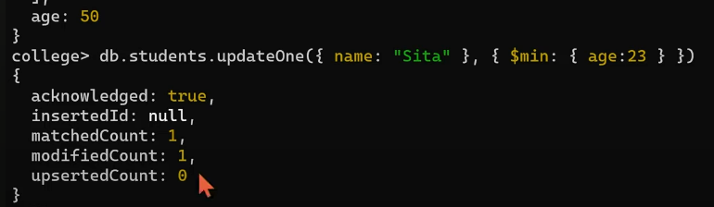

Idhar existing age:50 thi jo ki badi thi 23 se so hamne 50 ki jagah 23 set kar diya.

5.$max 🡪 agar existing value choti hai toh use bada kar hamari di gai value se badal do.

6.$mul 🡪

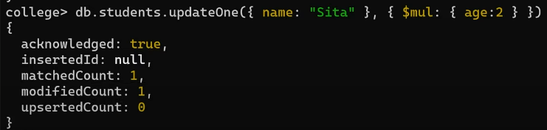

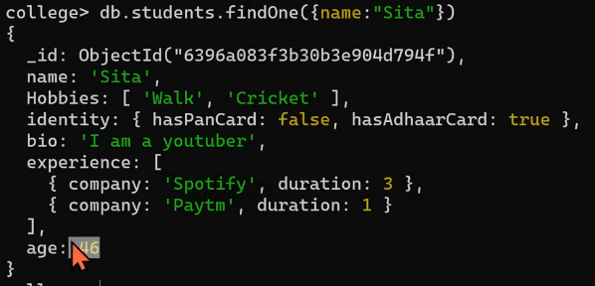

7.$unset 🡪 it just remove that field. 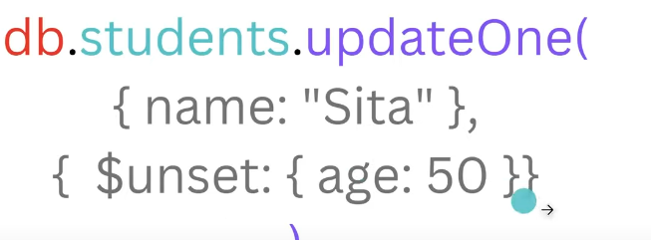

8.$rename 🡪just rename the given data field 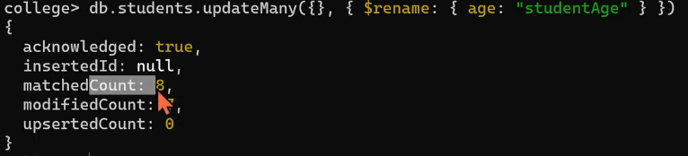

9.$upsert 🡪 if upsert:true then if the given data field is not vailable then put in it. 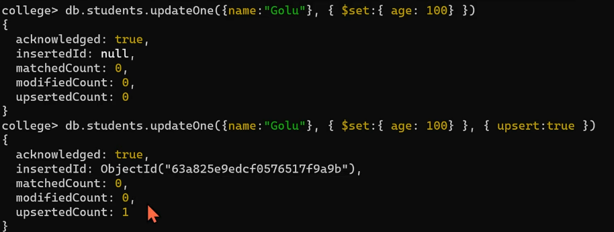

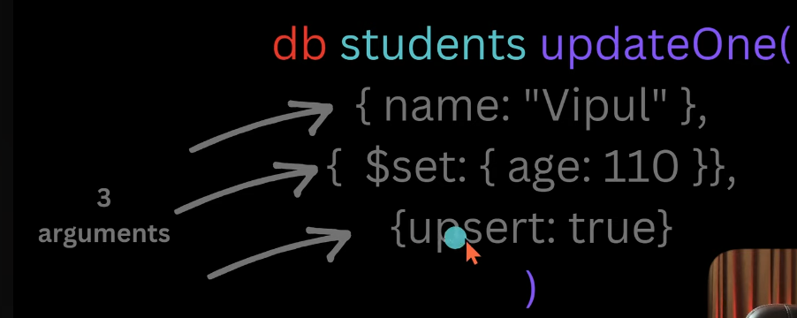

**#UPDATE NESTED ARRAYS**

1. 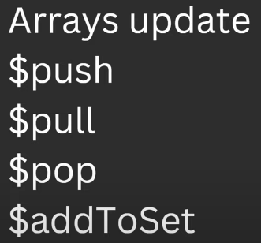

**#INDEXING**

1.If the datafeilds are not indexed then the searching is done called linear search or COLLSCAN.

2.Index based searching in MongoDB called as IXSCAN.

3. 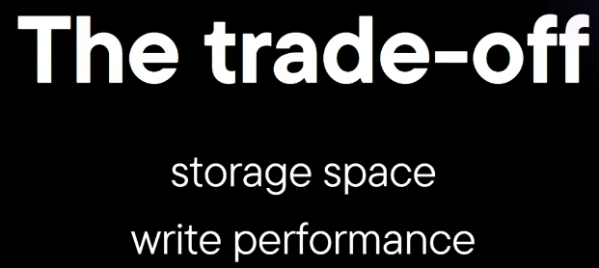

Iska mtlb kya hua ki IXSCAN ke liye storage bahut lagata hai kyunki isme hamara ek separate B-Tree banega na joki alag space leta hai.

So IXSCAN wahi accha hai jaha jada kaam read operation ka ho naki write operation ka .

Agar write operation hoga toh phirse B-Tree banana padega na .

4.For checking how MongoDB search or do operations just put .explain() in the last of your query. 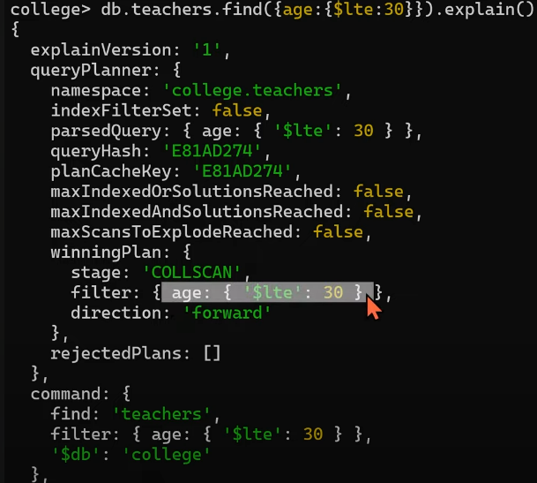

5.For just checking the execution stat put 

**#BUCKET OPERATOR**

1.When we have a situation that make groups of students then we use $bucket 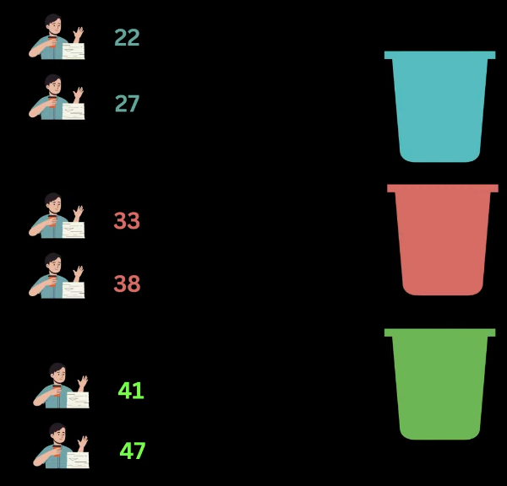

2.Suppose we have given teachers data 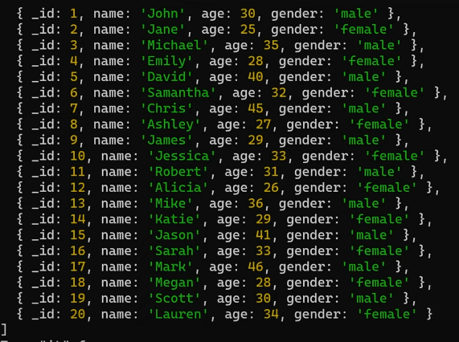

3.Now we have to make grps like 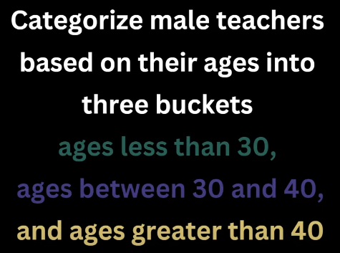

4.Now first make a group of all males. 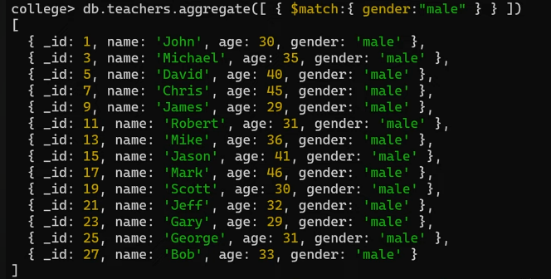

5.Here .aggregate() function first take the list of operations.

6.Syntax: 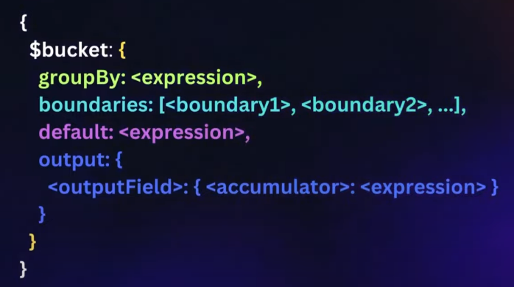

7.

8.

**#**

1.

2.

3.

4.

5.

**#**

1.

2.

3.

4.

5.